SQL RDBMS Best Practices and Industry Standards for Developers

- Create Database
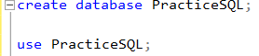

- Create Tables (DDL)
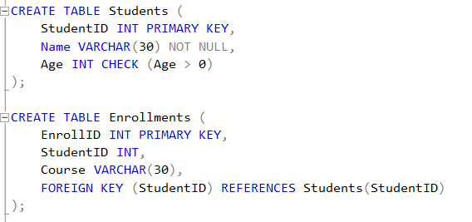
- Insert Data (DML)
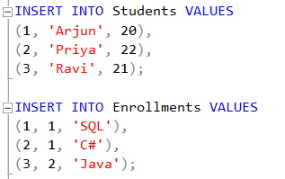
- Select (DQL)
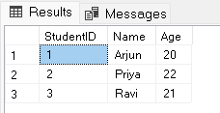
- INNER JOIN
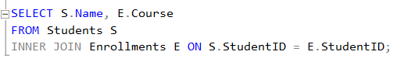

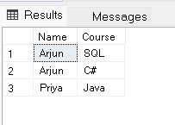
- LEFT JOIN (shows students with no course)
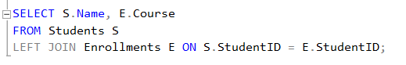

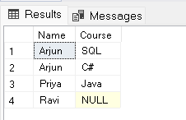
- Subquery (IN)
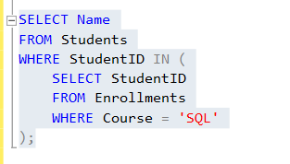

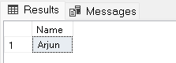
- CTE Example
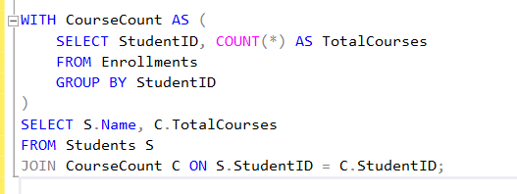

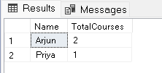
- Window Function (ROW_NUMBER)
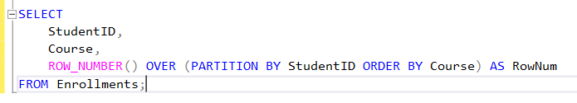

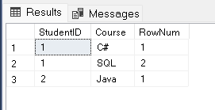

- Transaction (COMMIT / ROLLBACK)
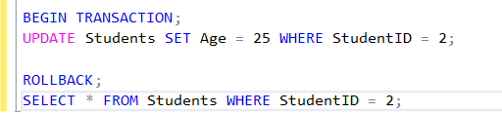

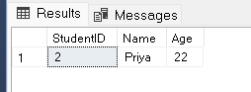
- Index Practice
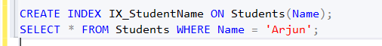

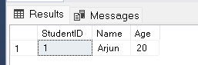
- Update + Delete
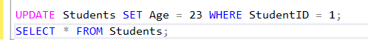
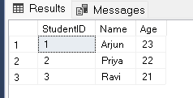

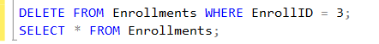
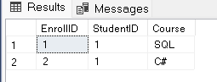
13) PRIMARY KEY And FOREIGN KEY Test
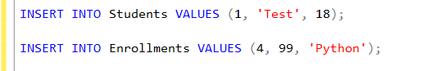
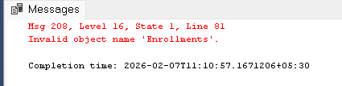
14) NOT NULL Test
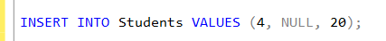
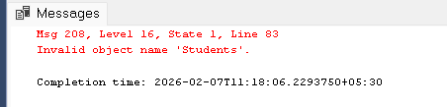
15) CHECK Constraint Test
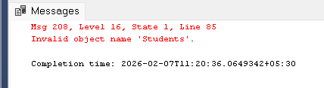
16) Stored Procedure
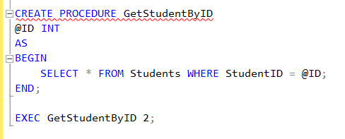
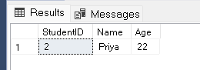

17) Cursor Practice
